Lucrarea de laborator nr. 7

**Samciucov Valentin**

Coder, decoder, unitate de memorie permanentă

# Scopul lucrării:

1. Studierea elementelor combinaţionale (coder, decoder) în regim static.
2. Studierea elementelor combinaţionale (coder, decoder) în regim dinamic.
3. Studierea și programarea unităţii de memorie permanentă.

# Experimentul nr. 1. Decoder

Tabelul 1. Tabelul de adevăr al decoderului

|  |  |  |  |  |  |  |  |  |  |  |  |  |  |  |  |  |  |  |  |  |
| --- | --- | --- | --- | --- | --- | --- | --- | --- | --- | --- | --- | --- | --- | --- | --- | --- | --- | --- | --- | --- |
| Nr. d/o | Intrarile | | | | Iesirile | | | | | | | | | | | | | | | |
| A | B | C | D | F15 | F14 | F13 | F12 | F11 | F10 | F9 | F8 | F7 | F6 | F5 | F4 | F3 | F2 | F1 | F0 |
| 0 | 0 | 0 | 0 | 0 | 0 | 0 | 0 | 0 | 0 | 0 | 0 | 0 | 0 | 0 | 0 | 0 | 0 | 0 | 0 | 1 |
| 1 | 0 | 0 | 0 | 1 | 0 | 0 | 0 | 0 | 0 | 0 | 0 | 0 | 0 | 0 | 0 | 0 | 0 | 0 | 1 | 0 |
| 2 | 0 | 0 | 1 | 0 | 0 | 0 | 0 | 0 | 0 | 0 | 0 | 0 | 0 | 0 | 0 | 0 | 0 | 1 | 0 | 0 |
| 3 | 0 | 0 | 1 | 1 | 0 | 0 | 0 | 0 | 0 | 0 | 0 | 0 | 0 | 0 | 0 | 0 | 1 | 0 | 0 | 0 |
| 4 | 0 | 1 | 0 | 0 | 0 | 0 | 0 | 0 | 0 | 0 | 0 | 0 | 0 | 0 | 0 | 1 | 0 | 0 | 0 | 0 |
| 5 | 0 | 1 | 0 | 1 | 0 | 0 | 0 | 0 | 0 | 0 | 0 | 0 | 0 | 0 | 1 | 0 | 0 | 0 | 0 | 0 |
| 6 | 0 | 1 | 1 | 0 | 0 | 0 | 0 | 0 | 0 | 0 | 0 | 0 | 0 | 1 | 0 | 0 | 0 | 0 | 0 | 0 |
| 7 | 0 | 1 | 1 | 1 | 0 | 0 | 0 | 0 | 0 | 0 | 0 | 0 | 1 | 0 | 0 | 0 | 0 | 0 | 0 | 0 |
| 8 | 1 | 0 | 0 | 0 | 0 | 0 | 0 | 0 | 0 | 0 | 0 | 1 | 0 | 0 | 0 | 0 | 0 | 0 | 0 | 0 |
| 9 | 1 | 0 | 0 | 1 | 0 | 0 | 0 | 0 | 0 | 0 | 1 | 0 | 0 | 0 | 0 | 0 | 0 | 0 | 0 | 0 |
| 10 | 1 | 0 | 1 | 0 | 0 | 0 | 0 | 0 | 0 | 1 | 0 | 0 | 0 | 0 | 0 | 0 | 0 | 0 | 0 | 0 |
| 11 | 1 | 0 | 1 | 1 | 0 | 0 | 0 | 0 | 1 | 0 | 0 | 0 | 0 | 0 | 0 | 0 | 0 | 0 | 0 | 0 |
| 12 | 1 | 1 | 0 | 0 | 0 | 0 | 0 | 1 | 0 | 0 | 0 | 0 | 0 | 0 | 0 | 0 | 0 | 0 | 0 | 0 |
| 13 | 1 | 1 | 0 | 1 | 0 | 0 | 1 | 0 | 0 | 0 | 0 | 0 | 0 | 0 | 0 | 0 | 0 | 0 | 0 | 0 |
| 14 | 1 | 1 | 1 | 0 | 0 | 1 | 0 | 0 | 0 | 0 | 0 | 0 | 0 | 0 | 0 | 0 | 0 | 0 | 0 | 0 |
| 15 | 1 | 1 | 1 | 1 | 1 | 0 | 0 | 0 | 0 | 0 | 0 | 0 | 0 | 0 | 0 | 0 | 0 | 0 | 0 | 0 |

Funcțiile logice ale decoderului cu 4 intrari:

1. F0=***
2. F1=***d
3. F2=**c*
4. F3=**c*d
5. F4=*b**
6. F5=*b**d
7. F6=*b*c*
8. F7= *b*c*d
9. F8=a***
10. F9=a***d
11. F10=a**c*
12. F11=a**c*d
13. F12=a*b**
14. F13=a*b**d
15. F14=a*b*c*
16. F15=a*b*c*d
17. **Regim static**

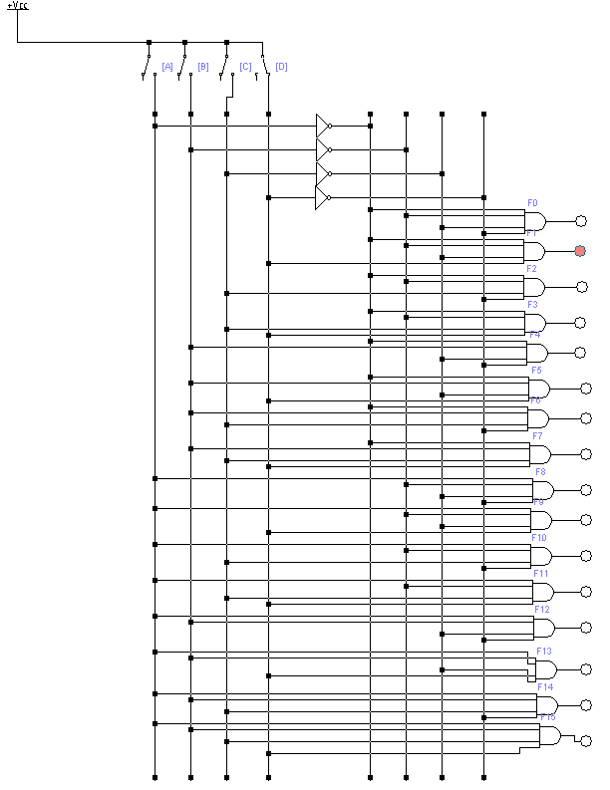

Fig. 1. Schema electrica a decoderului în regim static

1. **Regim Dinamic**

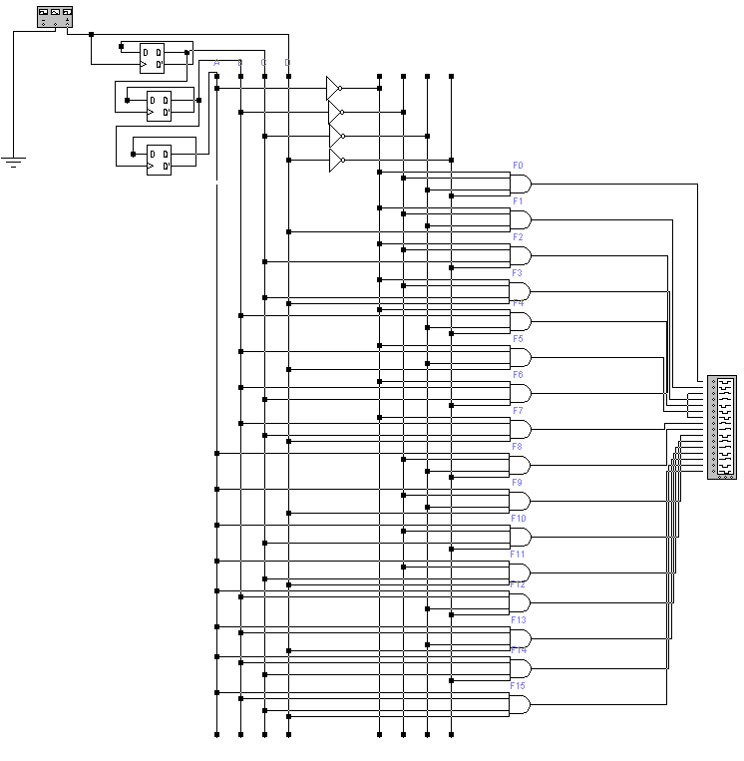

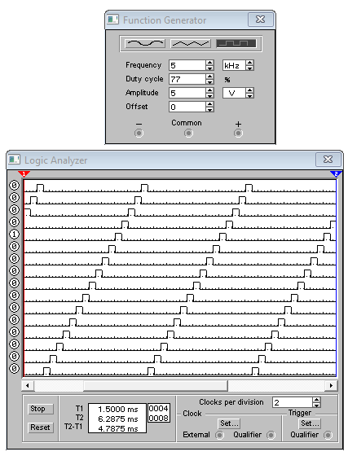

Fig. 2. Schema electrica a decoderului în regim dinamic

# Experimentul nr. 2. Coder

|  |  |  |  |  |  |  |  |  |  |  |  |  |  |  |  |  |  |  |  |  |  |  |
| --- | --- | --- | --- | --- | --- | --- | --- | --- | --- | --- | --- | --- | --- | --- | --- | --- | --- | --- | --- | --- | --- | --- |
| Nr. d/o | Intrarile | | | | | | | | | | | | | | | | | Iesirile | | | | |
| X16 | X15 | X14 | X13 | X12 | X11 | X10 | X9 | X8 | X7 | X6 | X5 | X4 | X3 | X2 | X1 | X0 | F4 | F3 | F2 | F1 | F0 |
| 0. | 1 | 1 | 1 | 1 | 1 | 1 | 1 | 1 | 1 | 1 | 1 | 1 | 1 | 1 | 1 | 1 | 0 | 0 | 0 | 0 | 0 | 0 |
| 1. | 1 | 1 | 1 | 1 | 1 | 1 | 1 | 1 | 1 | 1 | 1 | 1 | 1 | 1 | 1 | 0 | 1 | 0 | 0 | 0 | 0 | 1 |
| 2. | 1 | 1 | 1 | 1 | 1 | 1 | 1 | 1 | 1 | 1 | 1 | 1 | 1 | 1 | 0 | 1 | 1 | 0 | 0 | 0 | 1 | 0 |
| 3. | 1 | 1 | 1 | 1 | 1 | 1 | 1 | 1 | 1 | 1 | 1 | 1 | 1 | 0 | 1 | 1 | 1 | 0 | 0 | 0 | 1 | 1 |
| 4. | 1 | 1 | 1 | 1 | 1 | 1 | 1 | 1 | 1 | 1 | 1 | 1 | 0 | 1 | 1 | 1 | 1 | 0 | 0 | 1 | 0 | 0 |
| 5. | 1 | 1 | 1 | 1 | 1 | 1 | 1 | 1 | 1 | 1 | 1 | 0 | 1 | 1 | 1 | 1 | 1 | 0 | 0 | 1 | 0 | 1 |
| 6. | 1 | 1 | 1 | 1 | 1 | 1 | 1 | 1 | 1 | 1 | 0 | 1 | 1 | 1 | 1 | 1 | 1 | 0 | 0 | 1 | 1 | 0 |
| 7. | 1 | 1 | 1 | 1 | 1 | 1 | 1 | 1 | 1 | 0 | 1 | 1 | 1 | 1 | 1 | 1 | 1 | 0 | 0 | 1 | 1 | 1 |
| 8. | 1 | 1 | 1 | 1 | 1 | 1 | 1 | 1 | 0 | 1 | 1 | 1 | 1 | 1 | 1 | 1 | 1 | 0 | 1 | 0 | 0 | 0 |
| 9. | 1 | 1 | 1 | 1 | 1 | 1 | 1 | 0 | 1 | 1 | 1 | 1 | 1 | 1 | 1 | 1 | 1 | 0 | 1 | 0 | 0 | 1 |
| 10. | 1 | 1 | 1 | 1 | 1 | 1 | 0 | 1 | 1 | 1 | 1 | 1 | 1 | 1 | 1 | 1 | 1 | 0 | 1 | 0 | 1 | 0 |
| 11. | 1 | 1 | 1 | 1 | 1 | 0 | 1 | 1 | 1 | 1 | 1 | 1 | 1 | 1 | 1 | 1 | 1 | 0 | 1 | 0 | 1 | 1 |
| 12. | 1 | 1 | 1 | 1 | 0 | 1 | 1 | 1 | 1 | 1 | 1 | 1 | 1 | 1 | 1 | 1 | 1 | 0 | 1 | 1 | 0 | 0 |
| 13. | 1 | 1 | 1 | 0 | 1 | 1 | 1 | 1 | 1 | 1 | 1 | 1 | 1 | 1 | 1 | 1 | 1 | 0 | 1 | 1 | 0 | 1 |
| 14. | 1 | 1 | 0 | 1 | 1 | 1 | 1 | 1 | 1 | 1 | 1 | 1 | 1 | 1 | 1 | 1 | 1 | 0 | 1 | 1 | 1 | 0 |
| 15. | 1 | 0 | 1 | 1 | 1 | 1 | 1 | 1 | 1 | 1 | 1 | 1 | 1 | 1 | 1 | 1 | 1 | 0 | 1 | 1 | 1 | 1 |
| 16. | 0 | 1 | 1 | 1 | 1 | 1 | 1 | 1 | 1 | 1 | 1 | 1 | 1 | 1 | 1 | 1 | 1 | 1 | 0 | 0 | 0 | 0 |

Functiile logice:

F4 = $\overline{X16}$

F3 = $\overline{X15*X14*X13*X12*X11*X10*X9*X8}$

F2 = $\overline{X15*X14*X13*X12*X7*X6*X5*X4}$

F1 = $\overline{X15*X14*X11*X10*X7*X6*X3*X2}$

F0 = $\overline{X15*X13*X11*X9*X7*X5*X3*X1}$

1. **Regim Satatic**

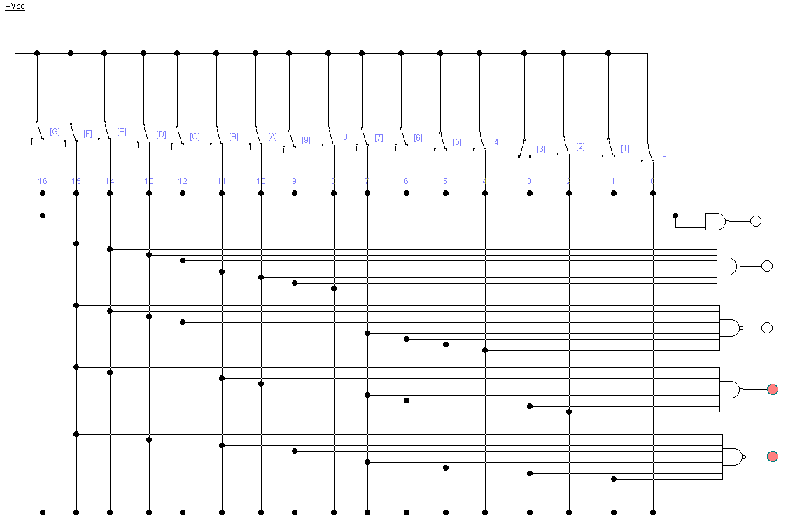

Fig. 3. Schema electrica a coderului în regim static

1. **Regim dinamic**

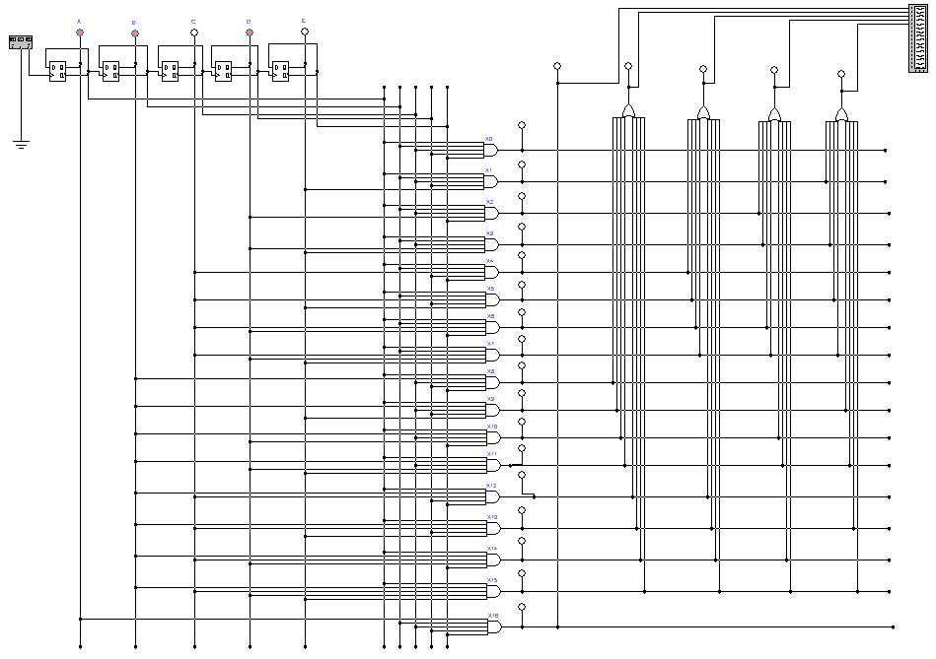

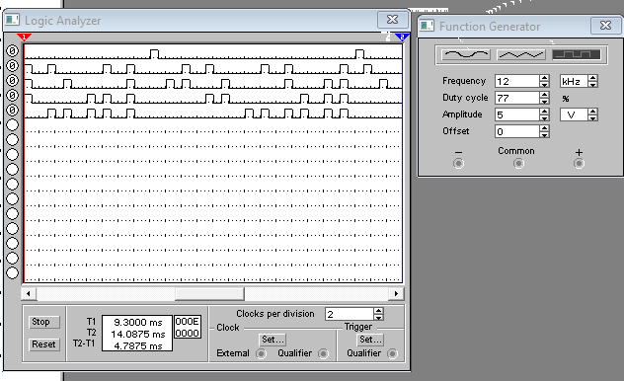

Fig. 4. Schema electrica a coderului în regim dinamic

# Experimentul nr. 3. Unitatea de memorie permanentă

1. **Regim Static**

Tabelul 3. Variantele programelor pentru unitatea de memorie permanentă

|  |  |
| --- | --- |
| A3 A2 A1 A0 | D4 D3 D2 D1 D0 |
| 0000 | 01010 |
| 0001 | 00111 |
| 0010 | 00110 |
| 0011 | 11100 |
| 0100 | 01100 |
| 0101 | 10100 |
| 0110 | 01111 |
| 0111 | 10110 |
| 1000 | 11101 |
| 1001 | 00110 |
| 1010 | 01011 |
| 1011 | 01100 |
| 1100 | 10101 |
| 1101 | 11011 |
| 1110 | 10101 |
| 1111 | 10011 |

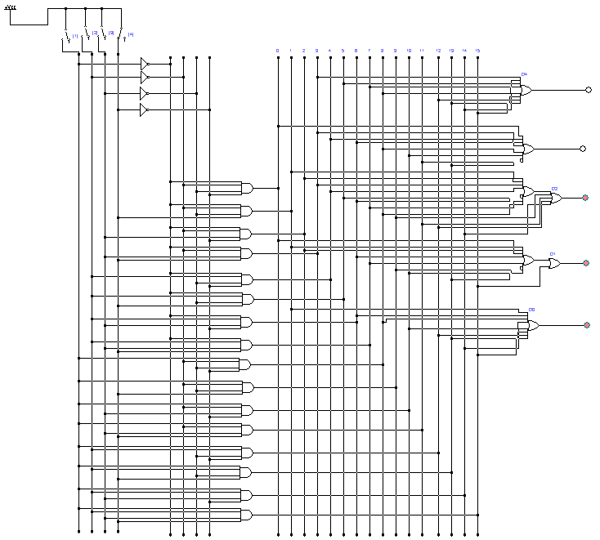

Fig. 5. Unitatea de memorie permanenta, regim static

1. **Regim dinamic**

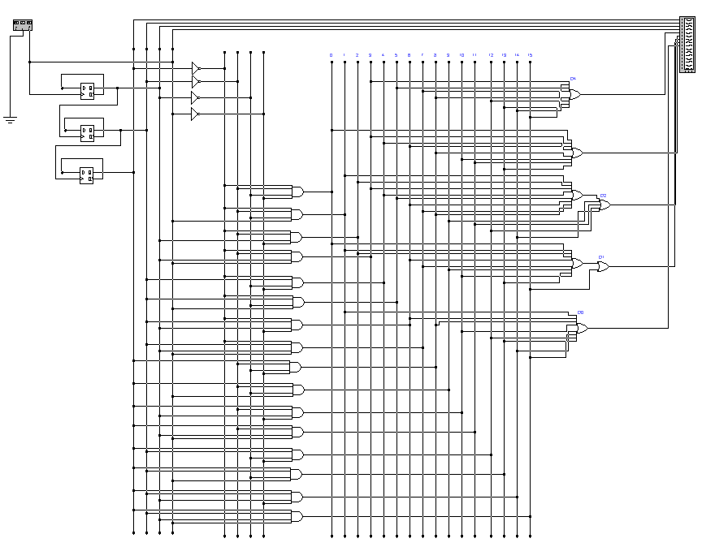

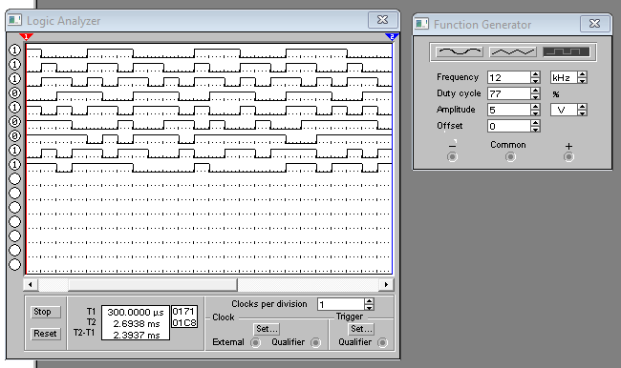

Fig. 6. Unitatea de memorie permanenta, regim dinamic